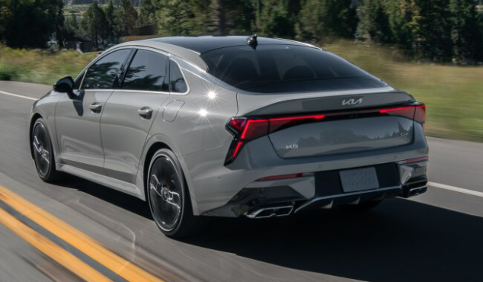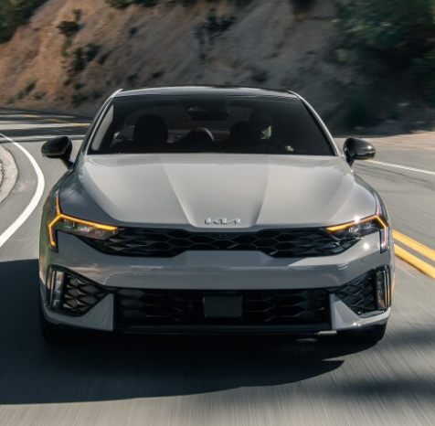

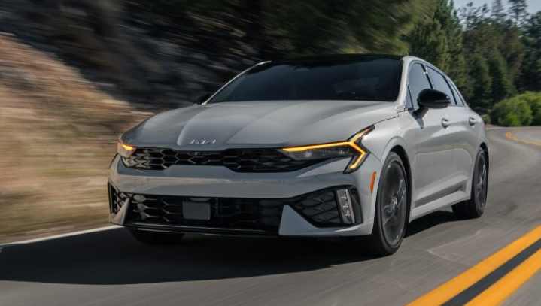

**Main specifications** of the **2025 Kia K5**:

**🔧 Powertrain & Performance**

* **Engine options**:
  + Base: 2.5 L naturally aspirated inline-4, **191 hp @ 6,100 rpm**, **181 lb‑ft torque @ 4,000 rpm**
  + GT: 2.5 L turbocharged inline-4 with **290 hp** and **311 lb‑ft** torque
* **Transmission**:
  + 8-speed automatic (base)
  + 8-speed dual-clutch automatic (GT)
* **Drivetrain**: FWD standard; AWD available on GT‑Line **Acceleration**: GT engine does 0–60 mph in ~5.2 s

**⛽ Fuel Economy (EPA est.)**

* **2.5 L NA (LXS)**: 26 mpg city / 37 mpg highway / 29 mpg combined highway
* **GT (290 hp)**: 23 city / 33 highway
* **GT-Line/EX AWD**: 24 city / 33

**📏 Dimensions & Capacity**

* **Length**: 4,905 mm (193.1 in)
* **Width**: 1,860 mm (73.2 in)
* **Height**: 1,445 mm (56.9 in)
* **Wheelbase**: 2,850 mm (112.2 in)
* **Curb weight**: ~3,230 lb (1,465 kg) for base; ~3,396 lb (1,542 kg) for turbo models **Cargo**: ~16.0 cu ft (442 L) trunk

**🛋 Interior & Tech**

* Seating for 5 adults
* Optional 12.3″ digital cluster and 10.3″ touchscreen
* Wireless Apple CarPlay/Android Auto; available Bose 12-speaker audio (EX/GT packs) Dual-zone climate control, rear vents, heated/ventilated seats (higher trims)

**🛡 Safety & Driver-Assist (Available Features)**

* Forward Collision Avoidance Assist (FCA), Blind-Spot Monitor, Lane Keep Assist, Adaptive Cruise Control with Stop & Go
* Optional: 360° Surround View Camera, Parking Sensors (front & rear), Head-Up Display (higher trims)

**🏁 Chassis & Comfort**

* Front: MacPherson strut; Rear: Multi-link independent
* Wheel options: 16″ (LXS), 18″ (GT‑Line/EX), 19″ (GT)

**✅ Quick Summary Table**

| **Feature** | **Details** |
| --- | --- |
| **Engines** | 2.5 L NA (191 hp); 2.5 L Turbo (290 hp GT) |
| **Transmissions** | 8‑speed auto; DCT in GT |
| **Drivetrain** | FWD / AWD (GT‑Line) |
| **Fuel Economy** | Up to 29 mpg combined (base) |
| **0‑60 mph** | ~5.2 s (GT) |
| **Dimensions** | 193 × 73 × 57 in; 112 in wheelbase |
| **Cargo Space** | 16.0 cu ft |
| **Infotainment** | 10–12″ screens, wireless CarPlay/Android |
| **Safety** | FCA, BSM, LKA, ACC (+ optional extras) |
| **Warranty** | 5 yr/60k mi basic, 10 yr/100k mi powertrain (typical US Kia) |